CENWP-OD-B
29 April 2009
MEMORANDUM FOR THE RECORD

SUBJECT: Three chinook mortalities from Bonneville’s Powerhouse Two Downstream Migration Channel (DSM2).

On 27 April, Pacific States Marine Fisheries Commission (PSMFC) reported to Project Fisheries that three adult chinook morts were collected off the separator bars. The three chinook morts arrived at 1710 after two live fall backs crossed the bars. This followed the water-up of DSM2 after the Powerhouse 2 (PH2) T11/12 line trip at 1415 the same day. The line trip resulted in a loss of power to PH2 causing the emergency relief gate in DSM2 to open. Project Fisheries conducted an inspection and verified that the flushing water to the two-mile pipe engaged.

PSMFC froze the chinook for examination. There was one unclipped adult, one clipped adult, and one clipped jack. At 0800 on 29 April, Project Fisheries arrived at the SMF to examine the fish. The fish were released into the flume at the SMF lower switch gate.

- Species – Chinook.
- Origin – Unknown
- Length x Girth – Unclipped adult – 37.25 x 22.5 inches, clipped adult – 29.0 x 18.0 inches, clipped jack – 19.5 x 10.75 inches.
- Weight – Unknown
- Injuries noted – Evidence of pinniped predation marks on the clipped adult.
- Marks noted – Two adipose clipped and one unclipped.
- Cause and Time of Death – Loss of flushing water in DSM2 prior to water-up approximately between 1600 and 1700 on 27 April.
- Future and Preventative Measures – Adjust flushing water to disengage after DSM2 reaches normal channel elevation.
- Other- The fish were scanned for PIT tags but none were present.

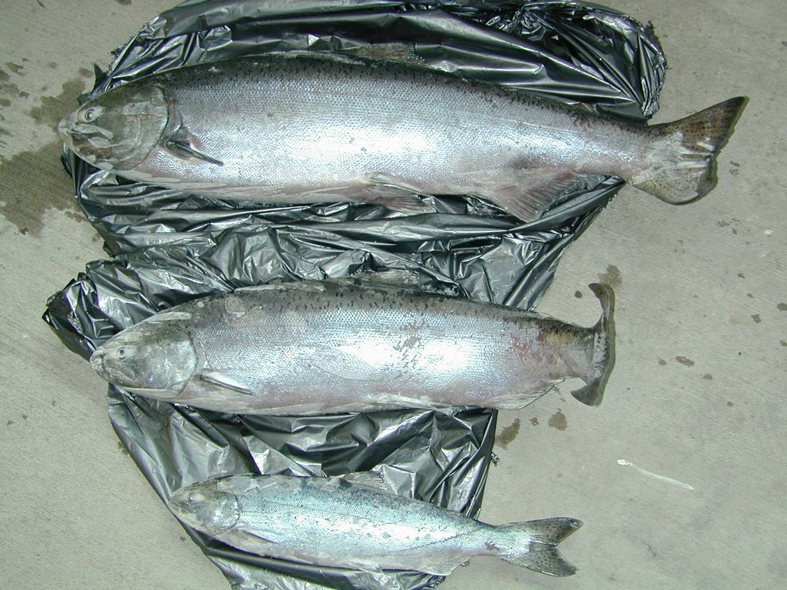

Bonneville Fisheries

